PYTHON-10 |
FILE HANDLING
File handling is the process of working with files on a computer. In Python, you can perform various operations like reading, writing, and manipulating files. Files can be used to store data persistently and are essential for many applications.

1. Opening a File:
To open a file in Python, you can use the `open()` function with the file name and mode as parameters. The mode indicates the purpose of file opening, such as read ('r'), write ('w'), append ('a'), etc.

2. Closing a File:
After performing operations on the file, it's essential to close it using the `close()` method to release system resources.

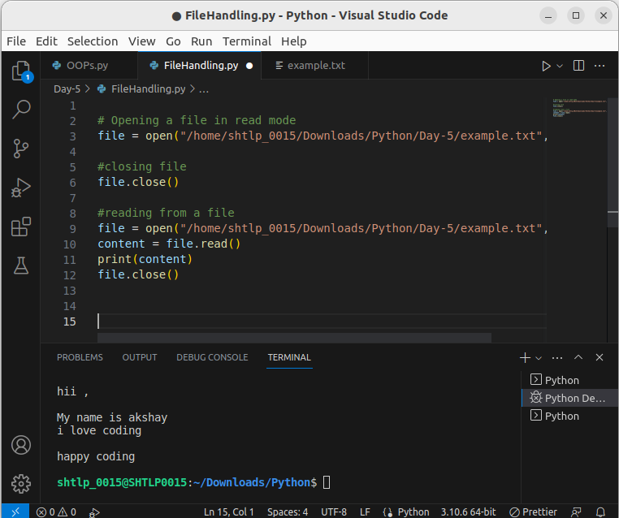

4. Modes of Opening Files
Modes for opening files in Python determine how the file can be accessed and manipulated. The `open()` function accepts a second argument, the mode, which specifies the purpose of opening the file. Here are the different modes for opening files:

1. “r" (Read Mode):
- Open the file for reading (default mode).
- The file pointer is positioned at the beginning of the file.
- Raises a `FileNotFoundError` if the file does not exist.

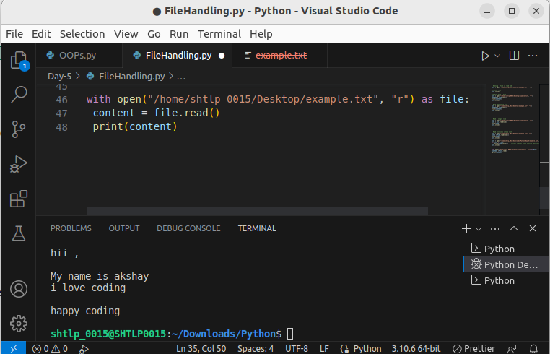

2. "w" (Write Mode):
- Open the file for writing.
- If the file exists, its contents are truncated (removed) before writing.
- If the file does not exist, a new file is created.
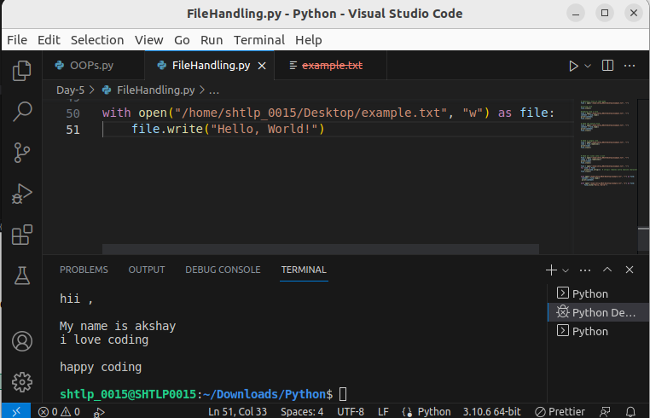

3. "a" (Append Mode):
- Open the file for appending.
- The file pointer is positioned at the end of the file.
- Data is added to the end of the file without overwriting existing content.

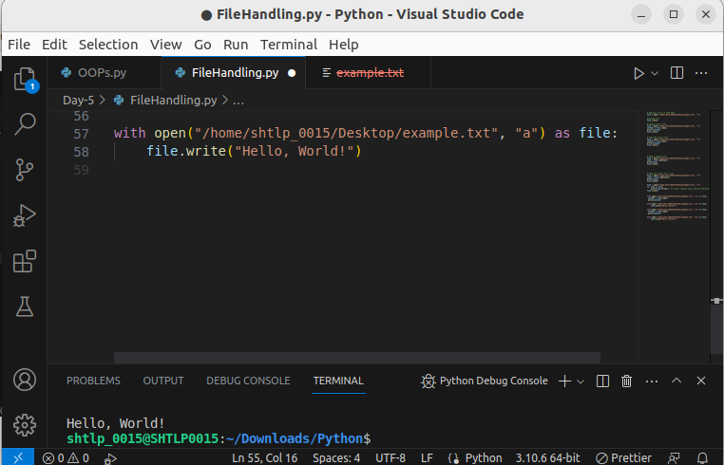

4. "x" (Exclusive Creation Mode):
- Open the file for exclusive creation.
- Raises a `FileExistsError` if the file already exists.

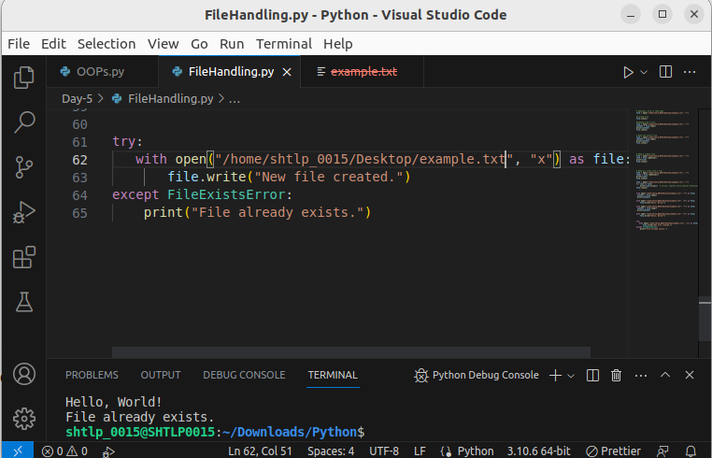

3. Reading from a File:
You can read data from a file using various methods. `read()` reads the entire file, `read(n)` reads n characters, `readline()` reads a single line, and `readlines()` reads all lines into a list.

1. read() : Read the entire file
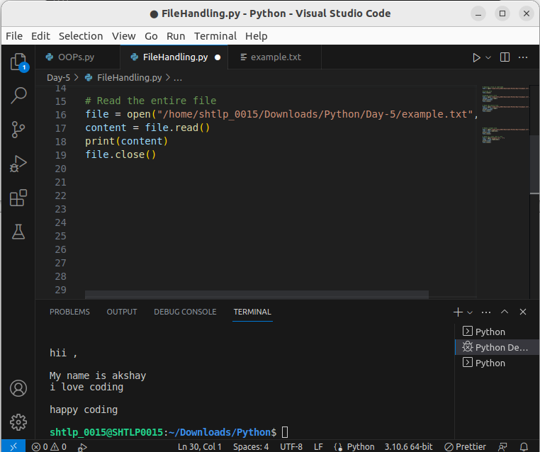

2.readline(): Read a single line

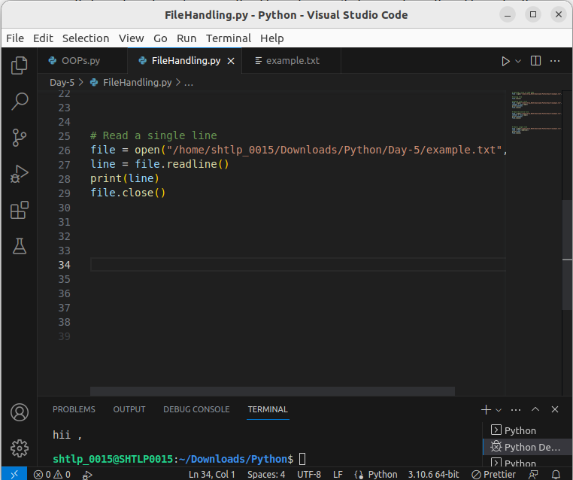
.

3. readlines(): Read all lines into a list
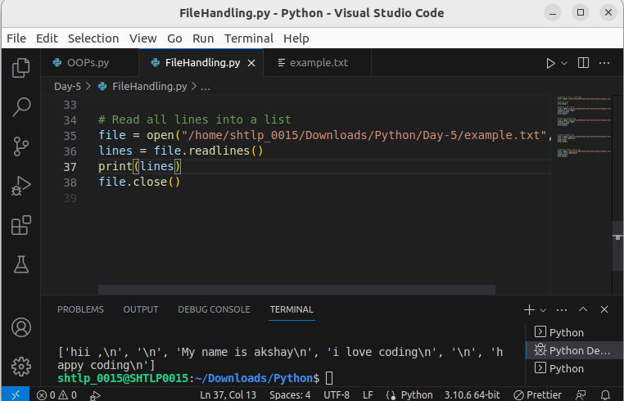

4. Iterating Over Lines of a File:
You can use a `for` loop to iterate over each line of a file and process them one by one.

Certainly! Iterating over lines of a file using a `for` loop is a common approach to read and process each line of a file. Here's how you can do it:

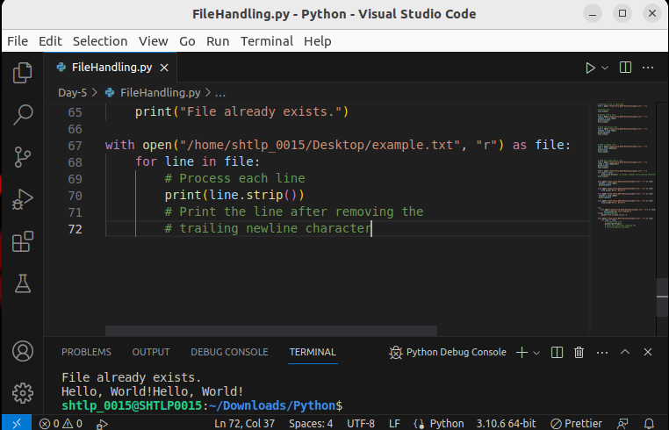

In this example, the `with` statement is used to open the file named "example.txt" in read mode. The `for` loop iterates over the file, and in each iteration, the variable `line` contains the content of the current line. The `strip()` method is used to remove the trailing newline character from each line before printing it.

This approach is memory-efficient as it reads and processes one line at a time, which is particularly useful when working with large files.

5. Clearing Data from a File:
You can clear the contents of a file using the `truncate()` method. Be cautious, as it will delete all data in the file.

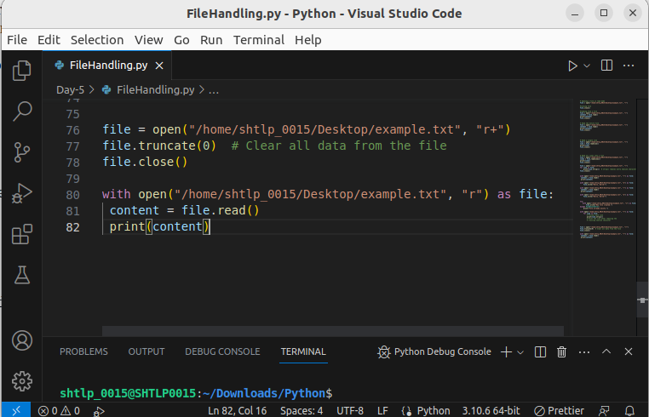

6. Writing to a File:
You can write data to a file using the `write()` method. It will overwrite existing data if the file is opened in 'w' mode.

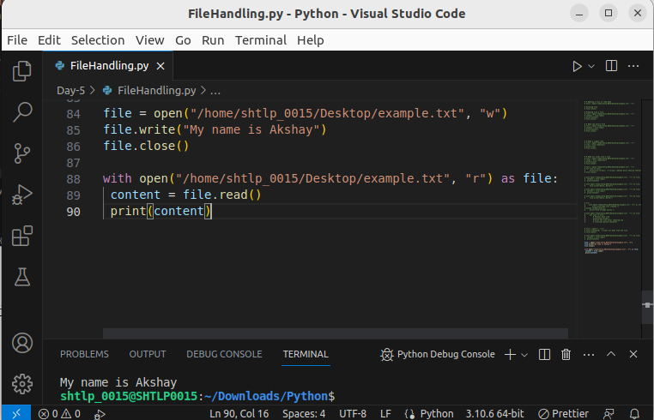

```The writelines() method in Python is used to write a list of lines to a file. Each element in the list represents a line of text. This method is useful when you want to write multiple lines of text to a file simultaneously. Here's how you can use the writelines() method:

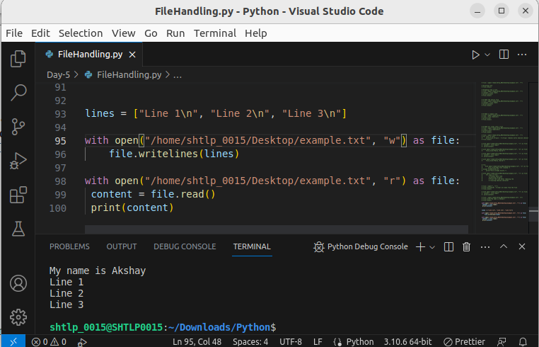

7. Appending to a File:
To add data to the end of an existing file without overwriting, open the file in 'a' mode and use the `write()` method.

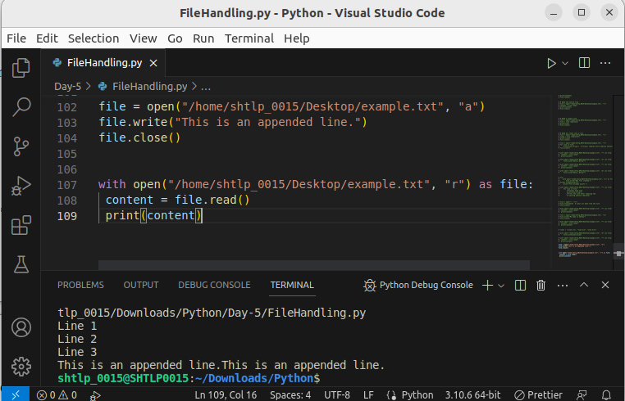

8. Difference Between Write and Append Modes:
In 'w' mode, writing to a file will create a new file or overwrite the existing one, while in 'a' mode, writing appends data to the end of an existing file.

9. Using the `with` Statement:
The `with` statement automatically handles file closing after its suite is executed.

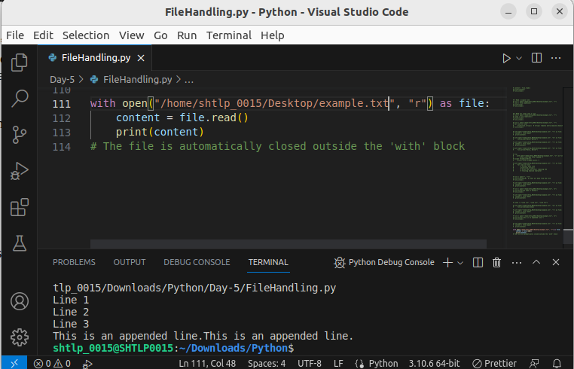

10. Working with CSV Files:
You can use the `csv.reader` and `csv.writer` methods from the `csv` module to read and write data in CSV files.

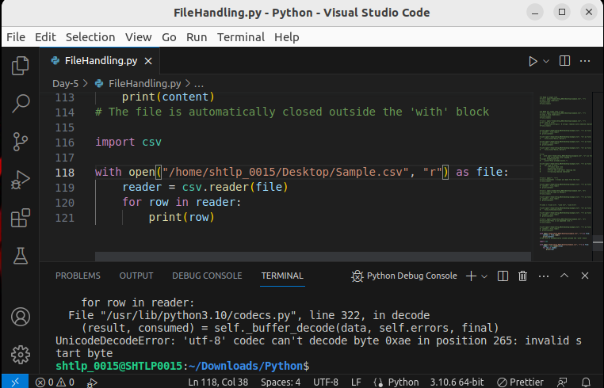

Example of writing to a CSV file:
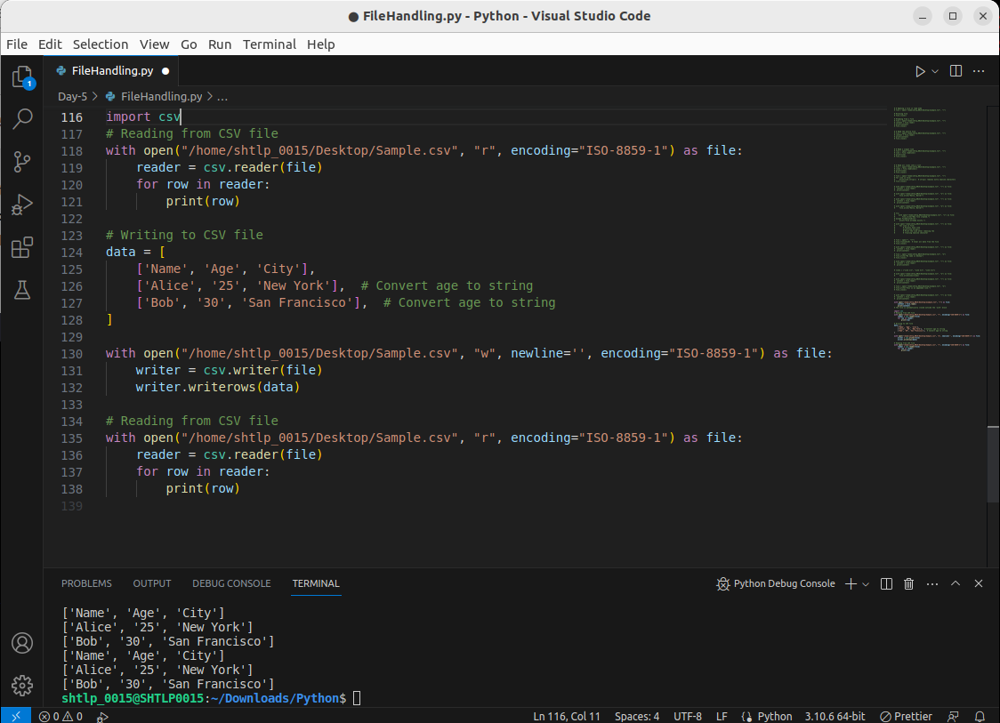
In these examples, we demonstrated the various file handling operations in Python, including opening, reading, writing, and closing files, as well as working with CSV files. Proper file handling helps ensure the integrity and security of data stored in files and enhances the efficiency of Python programs that interact with external data sources.

